VOLLEYBALL
Volleyball History
Volleyball was invented in 1895 by William G. Morgan in Holyoke, Massachusetts and was originally called “mintonette.” Morgan designed volleyball while working at a YMCA. He wanted it to be a combination of handball, tennis, baseball and basketball. The Spalding Company provided the first official ball made of soft calfskin. In 1930, the first two-man beach game was played. The sport was introduced to the Olympic Games in Tokyo in 1964.

Volleyball Vocabulary

Base Formation: A team’s ready position while its opponents play the ball

Block: When a player jumps, extending both arms over the net, with hands in a wide position, fingers spread, to block the opponent’s spike

Dig: A one or two armed save in which a player saves the ball from hitting the ground, so a teammate can play it

Forearm Pass: The passing action in which the ball hits off a player’s forearms and is directed to a teammate, also called a bump

Serve: The act of putting the ball into play. Servers must hit the ball behind the end line and into the opponent’s court

Set: Hitting the ball high so that the spiker can attack

Spike: A ball hit downward, with hard force, over the net and lands on opponent’s court
Volleyball Objectives

Forearm Pass (bump) (April 28th- May 5th)

- Students will demonstrate keeping body behind the ball.
- Students will demonstrate keeping arms straight, thumbs together, knees bents and weight forward.
- Students will understand a forearm pass is when the ball strikes a player’s forearms and is directed to a teammate.
- Students will understand a forearm pass is also called a “bump”.
- Students will work hard to be the best they can be.

Set (May 5th- May 12th)

- Students will demonstrate bending knees and getting body under the ball.
- Students will demonstrate thumbs together and index fingers together forming a triangle.
- Students will demonstrate pushing the ball with fingerpads, extending arms through the ball and finishing like Superman.
- Students will understand a set is when you hit the ball high so that the spiker can attack.
- Students will work hard to be the best they can be.

Underhand serve (May 12th- May 19th)

- Students will demonstrate a staggered stance-one foot slightly ahead of the other foot.
- Students will demonstrate holding the ball with non-throwing hand at waist level.
NOTE: DO NOT THROW BALL IN AIR
- Students will demonstrate striking the ball with an open OR closed hand,extending arm backwards, striking the ball with the HEEL of the palm and following through towards the target.
- Students will understand that servers must serve the ball behind the end line and into the opponent’s court.
- Students will work hard to be the best they can be

Overhand serve (May 19th- May 26th)

- Students will demonstrate stepping forward with foot opposite of striking hand.
- Students will demonstrate holding the ball with non-throwing hand and tossing the ball slightly above head.
- Students will demonstrate striking the ball with the PALM of their striking hand (open hand) and following through towards the target.
- Students will understand that servers must serve the ball behind the end line and into the opponent’s court.
- Students will work hard to be the best they can be.

Volleyball Drills for Home
-if you don’t have a volleyball, you can use other appropriate sized balls, stuffed toys or balloons. You can also practice your form without using an object.

https://www.youtube.com/watch?v=gdB06H38onc

https://www.youtube.com/watch?v=m-wtwOERx_Q

https://www.youtube.com/watch?v=Foj6A4WWgCg&t=108s

Volleyball Skills

Forearm Pass (bump) (April 28th- May 5th)

CUES:
- Body behind ball
- Arms straight
- Thumbs together
- Knees bent
- Weight forward (on toes)
- Swing arms up
NOTE: KEEP ARMS BELOW HEAD

Forearm passing videos

https://www.youtube.com/watch?v=siDVtYyRG_M

https://www.youtube.com/watch?v=SL5PRs35lvA

https://www.youtube.com/watch?v=hsTAXPYw2e8
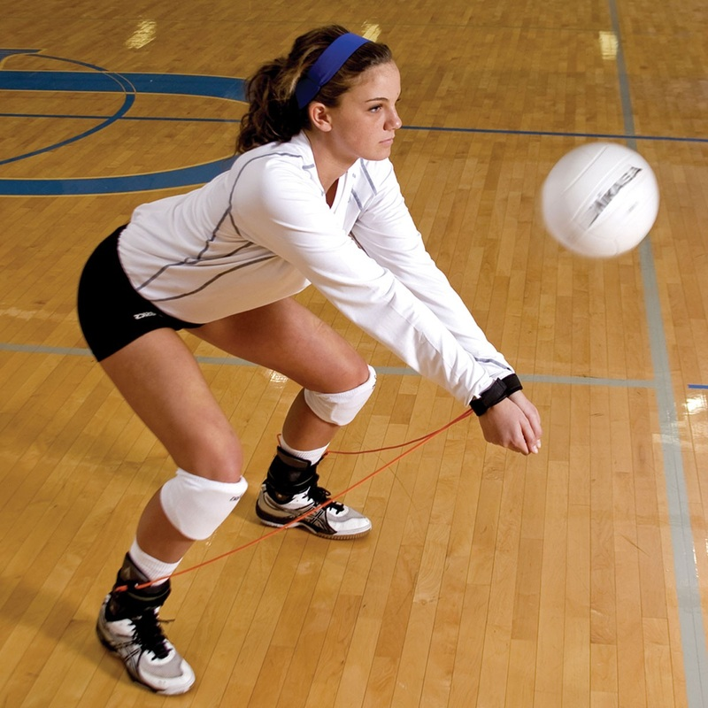
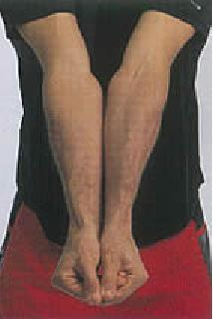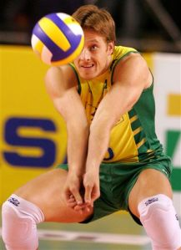

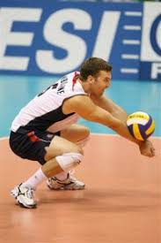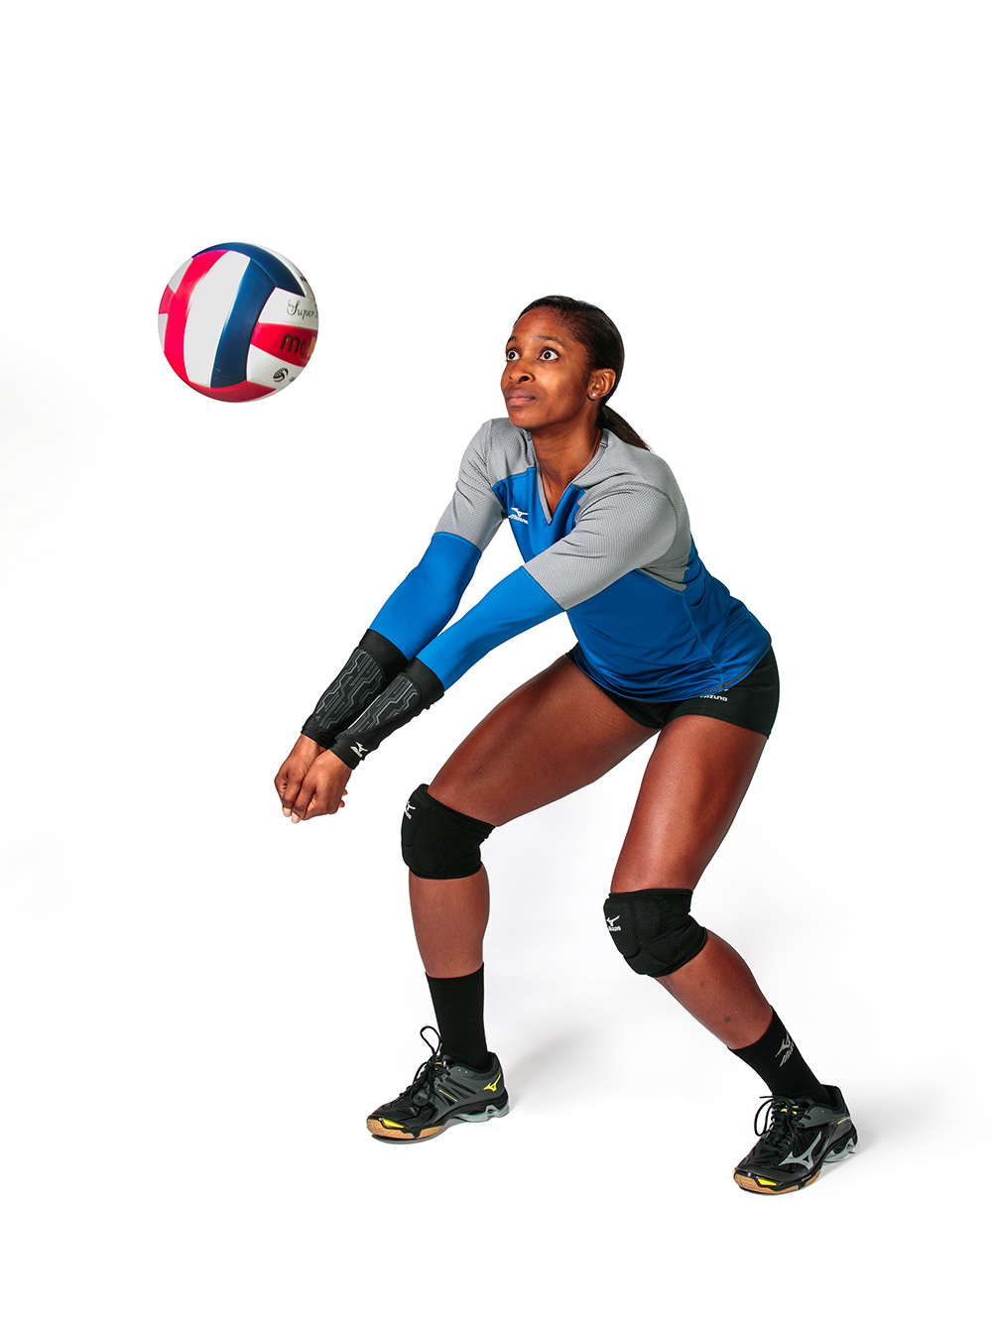
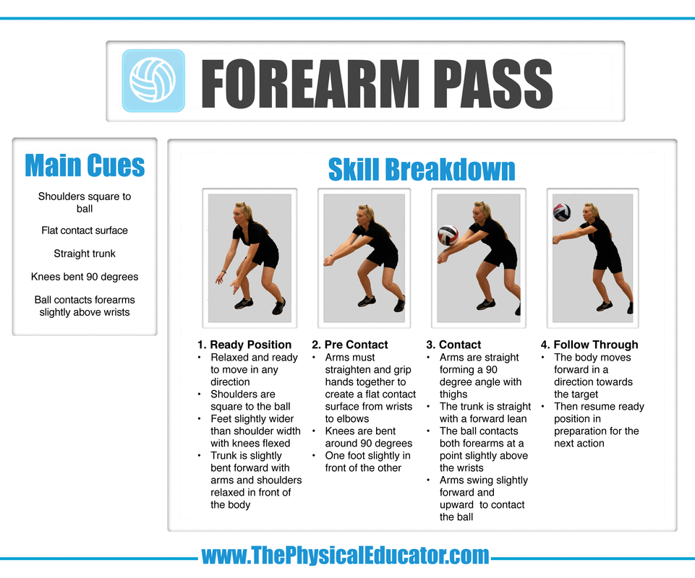
Set (May 5th- May 12th)

CUES:
- Body under ball
- Bend knees, bend elbows
- Thumbs together, index fingers together (forming a triangle)
NOTE: “LOOK THROUGH WINDOW”
- Push ball with fingerpads
- Finish like Superman!

Set videos

https://www.youtube.com/watch?v=d6FYi2TVm1I

https://www.youtube.com/watch?v=prSfG7gN7Js

https://www.youtube.com/watch?v=GX49gLs6piU

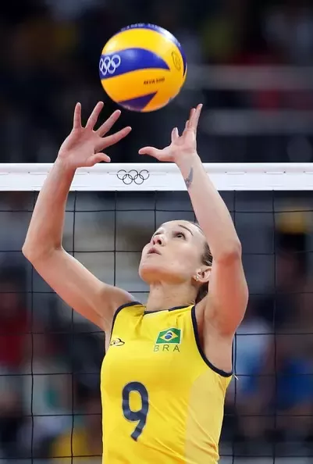

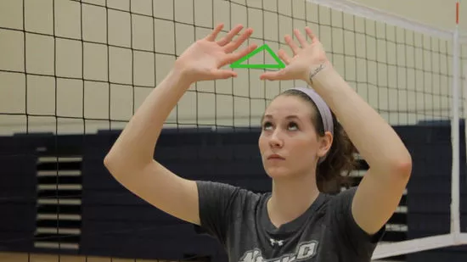

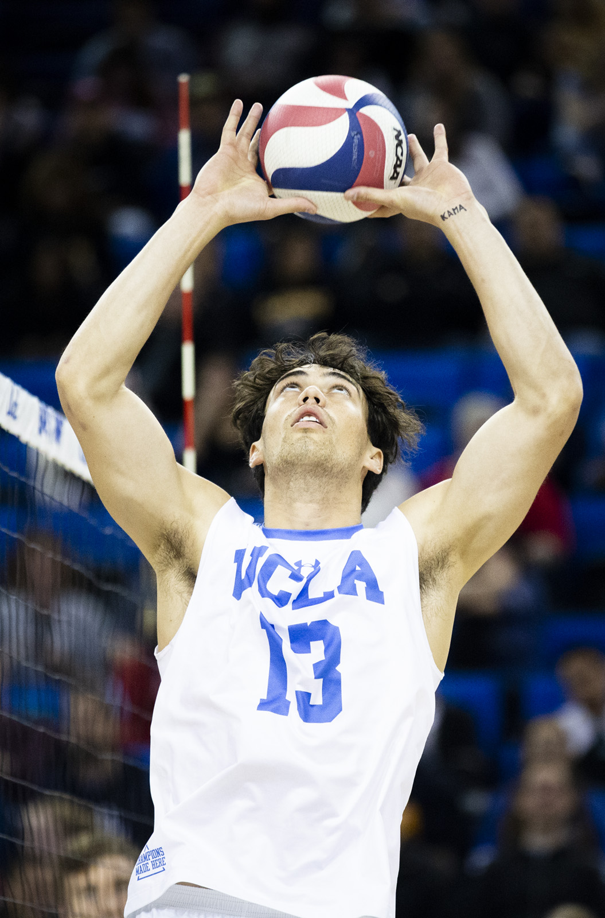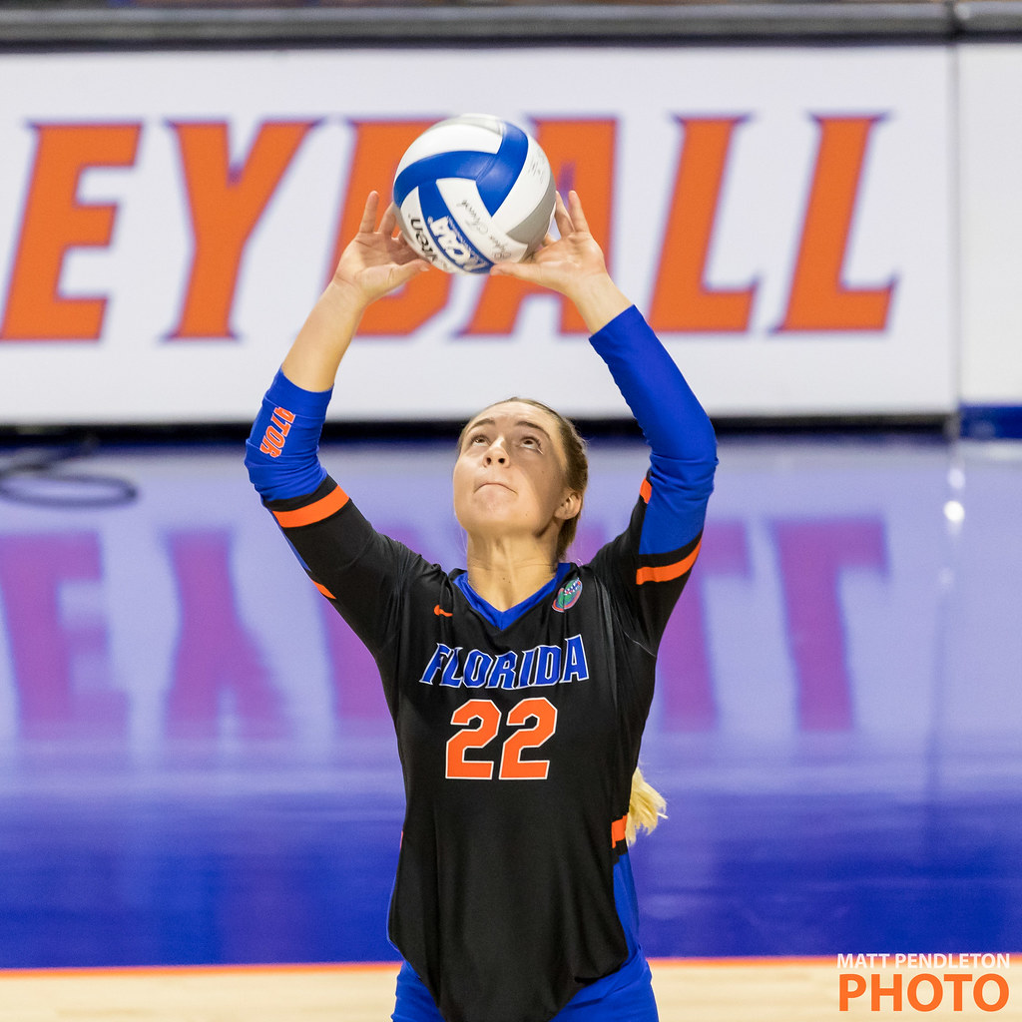
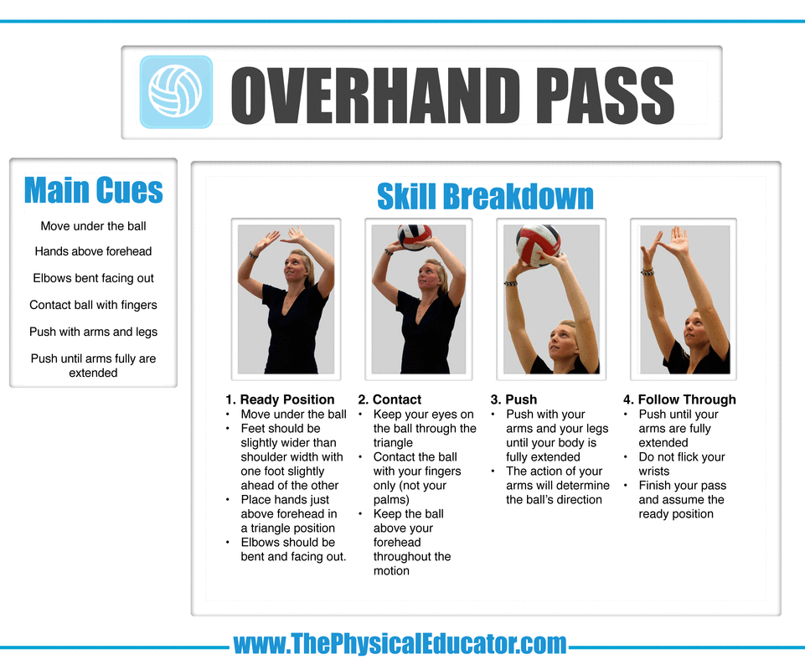
Underhand serve (May 12th- May 19th)

CUES
- Staggered stance- one foot slightly ahead of the other
- Hold ball, do not throw
- Strike ball with heel of palm
- Follow through

Underhand serve videos

https://www.youtube.com/watch?v=A0epDjKO6wg

https://www.youtube.com/watch?v=kZFbkbqG7J8

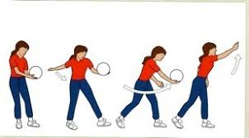

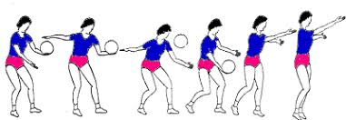

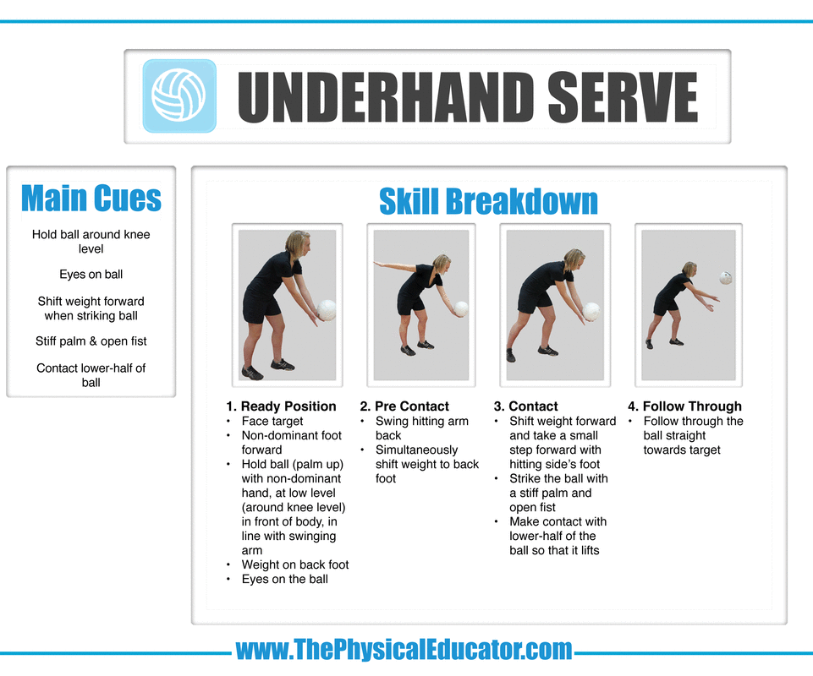
Overhand serve (May 19th- May 26th)

CUES
- Step forward with foot opposite of striking hand
- Toss ball
- Strike with open hand- PALM
- Transfer weight- back foot to front foot
- Follow through

Overhand serve videos

https://www.youtube.com/watch?v=7XkDMH8IX7U

https://www.youtube.com/watch?v=SnG7XJDunzs&list=TLPQMjMwNDIwMjDNzT_wQlRMRA&index=5

